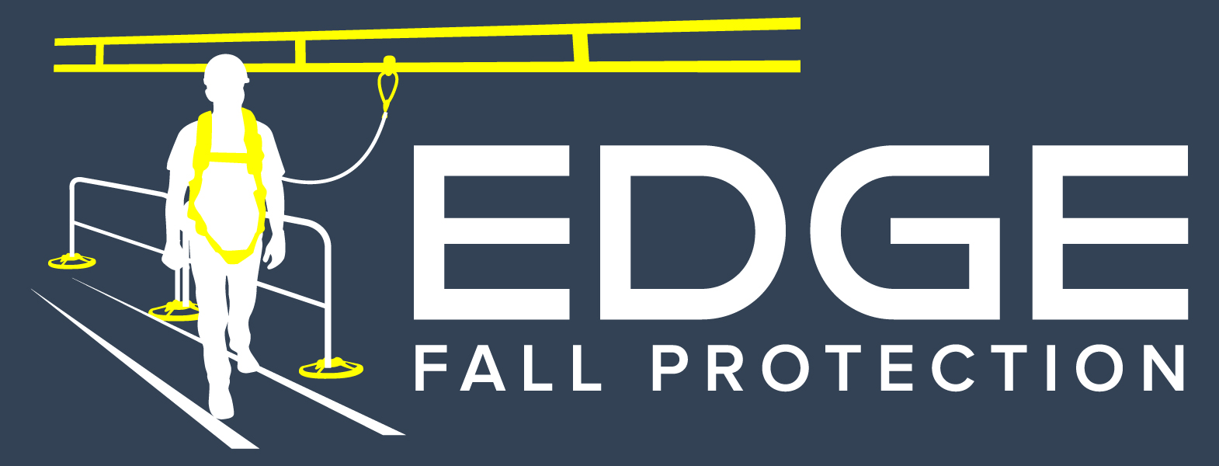

SECTION 118129

Facility Fall Protection

sales@edgefallprotection.com
www.edgefallprotection.com

- GENERAL

  - SECTION INCLUDES

    - Climbing Ladder Fall Arrest System - CLAFS

  - RELATED SECTIONS

    - Section 05500 – Metal Fabrications: Associated metal supports.

    - Section 05510 – Metal Stairs and Ladders.

    - Section 05515 – Ladders.

    - Section 07700 – Roof Specialties and Accessories.

  - REFERENCES
    - Occupational Safety & Health Administration (OSHA)
      - 29 CFR 1910.23(c) (1) & 29 CFR 1926.501(b) (1) - Occupational Health and Safety Standards General Industry & Construction: Duty to have fall protection
      - 29 CFR 1926.502(d) (15) (i-ii) - Safety and Health Regulations for Construction: Anchor Design Requirements
      - 29 CFR 1910.66 I(c) (10), I (d) (iv), II (2) - General Industry: Anchor Design Requirements
    - American National Standards Institute (ANSI)
      - Z359.0 – Definitions and Nomenclature Used for Fall Protection and Fall Arrest.
      - Z359.1 – Safety Requirements for Personal Fall Arrest Systems, Subsystems and Components
      - Z359.2 – Minimum Requirements for a Comprehensive Managed Fall Protection Program
      - Z359.3 – Safety Requirements for Positioning and Travel Restraint Systems.
      - Z359.4 – Safety Requirements for Assisted-Rescue and Self-Rescue Systems, Subsystem and Components.
      - Z359.6 – Specifications and Design Requirements for Active Fall Protection Systems.
      - Z359.12 – Connecting Components for Personal Fall Arrest Systems
      - Z359.13 – Personal Energy Absorbers and Energy Absorbing Lanyards
      - Z359.14 – Safety Requirements for Self-Retracting Devices for Personal Fall Arrest and Rescue Systems.
    - Materials, Bolting, Finishing: American Society of Testing Materials (ASTM)
      - A36 - Standard Specification for Carbon Structural Steel.
      - A500 - Standard Specification for Cold-Formed Welded and Seamless Carbon Steel Structural Tubing in Rounds and Shapes
      - A53 - Standard Specification for Pipe, Steel, Black and Hot-Dipped, Zinc-Coated, Welded and Seamless
      - A325 - Standard Specification for Structural Bolts, Steel, Heat Treated, 120/105 ksi Minimum Tensile Strength
      - A193 - Standard Specification for Alloy-Steel and Stainless Steel Bolting for High Temperature or High Pressure Service and Other Special Purpose Applications
      - A123 - Standard Specification for Zinc (Hot-Dip Galvanized) Coatings on Iron and Steel Products
      - A666 - Standard Specification for Austenitic Stainless Steel Sheet, Strip, Plate, and Flat Bar.
    - American Welding Society (AWS) D1.1/D1 - Structural Welding Code – Steel
    - Design Standards
      - American Institute of Steel Construction (AISC) 325-11 [14th ed.] – Steel Construction Manual
      - National Design Specification (ANSI/NDS) – Wood Construction Manual
      - International Building Code (IBC) [2012] – Building Design Manual
      - American Society of Civil Engineers (ASCE/SEI) 7-10 – Minimum Design Loads for Buildings and Other Structures
      - American Concrete Institute (ACI) 318-11 Building Code Requirements for Structural Concrete.

  - SUBMITTALS

    - Submit under provisions of Section 01300.

    - Product Data: Manufacturer's data sheets on each product to be used, including:
      - Preparation instructions and recommendations.
      - Storage and handling requirements and recommendations.
      - Installation methods.

    - Shop Drawings: Drawings showing plans, elevations, sections and details of components. Show member sizes and part identification, fasteners, anchors, fittings and evidence of compliance with structural performance requirements.
    - Engineering
      - The design shall take into consideration the potential uses of and loads on the ladder and the structure. To be completed by the Engineer of Record.

  - DELIVERY, STORAGE, AND HANDLING

    - Deliver materials to the job site in good condition and adequately protected against damage as handrails are a finished product.

    - Inspect components for damage before signing the receipt from the trucking company. Truck driver must note damaged goods on the bill of lading if damaged product is found

    - Store products in manufacturer's unopened packaging until ready for installation.

    - Products to be palletized and labeled by ladder.

  - PROJECT CONDITIONS

    - Field Measurements: Where systems are indicated to fit to ladder, check actual dimensions of other construction by accurate field measurements before fabrication.

  - WARRANTY

    - Warranty: Provide manufacturer’s limited two year warranty.

- PRODUCTS

  - MANUFACTURERS

    - Acceptable Manufacturer: Edge Fall Protection, LLC, which is located at in Minneapolis, MN 55419. Contact: E-mail: sales@edgefallprotection.com Website: www.edgefallprotection.com Toll Free/Fax: 844-314-1374.

    - Substitutions: Not permitted.

    - Requests for substitutions will be considered in accordance with provisions of Section 01600.

  - Climbing Ladder Fall Arrest System for Roof Hatch Access

    - Vertical Lifeline Ladder climbing System: Provide EDGE Fall Protection LLC’s Roof Hatch Ladder Fall Arrest System. Contact: sales@edgefallprotection.com; TF/Fax: 844-314-1374. System is a Vertical lifeline System
    - Roof Hatch Ladder Fall Arrest System with a Telescoping Extension.
      - Product: Roof Hatch Ladder Fall Arrest System
        - System top and mid rail provided in accordance with OSHA Standards - 29 CFR 1910.23 (a)(2).
      - System Length: Field Verify ladder height for appropriate system length
      - Top and Bottom Mounting Brackets for
        - Steel Rung
        - Telescoping Pole
      - Pre-swagged Cable
        - 3/8 in (9.5mm)
        - 1x7 strand
        - Left, Regular Lay
        - Galvanized
        - Compliance: RR-W-410
        - Minimum Breaking Strength: 12,000lbs
      - Cable Guides: Place as needed to prevent cable abrasion
        - Recommended every 20-40 ft
      - Hollow Rung Ladder Supports
        - To be included on all hollow rung ladders

- EXECUTION

  - EXAMINATION

    - Do not begin installation until ladders have been properly prepared and attached to substrate or structure.

    - If substrate preparation is the responsibility of another installer, notify Architect of unsatisfactory preparation before proceeding.

  - PREPARATION

    - Clean surfaces thoroughly prior to installation.

  - INSTALLATION

    - Install in accordance with manufacturer's instructions.

  - PROTECTION

    - Protect installed products until completion of project.

    - Touch-up, repair or replace damaged products before Substantial Completion.

END OF SECTION

