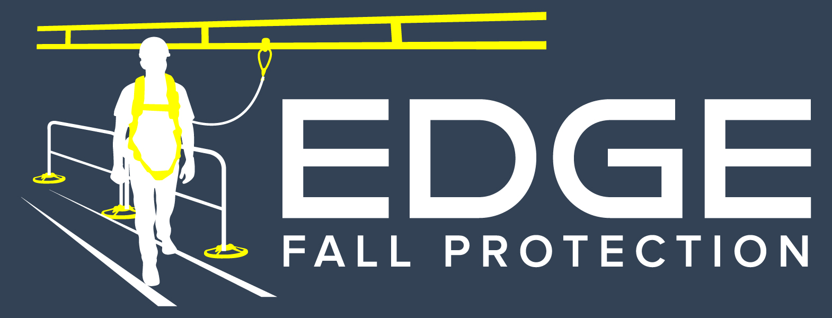

SECTION 05522

Metal Guardrail and Rooftop Fall protection

sales@edgefallprotection.com
www.edgefallprotection.com

- GENERAL

  - SECTION INCLUDES

    - Non-Penetrating Enduraline Permanent Visual Warning Line System

  - RELATED SECTIONS

    - Section 05500 – Metal Fabrications: Associated metal supports.

    - Section 05510 – Metal Stairs and Ladders.

    - Section 05515 – Ladders.

    - Section 07700 – Roof Specialties and Accessories.

    - Section 07400 – Membrane Roofing: Coordination of roof edge protection installation.

    - Section 07411 Membrane Roof Panels: Coordination of roof edge protection installations.

  - REFERENCES
    - Occupational Safety & Health Administration (OSHA)
      - 29 CFR 1910.23 – Guarding Floor and Wall Openings and Holes
      - 29 CFR 1910.27 - Fixed Ladders.
      - 29 CFR 1926.500 - Scope, Application, and Definitions Applicable to this Subpart.
      - 29 CFR 1926.501 - Duty to Have Fall Protection.
      - 29 CFR 1926.502 - Fall Protection Systems Criteria and Practices.
      - 29 CFR 1926.503 - Training Requirements.
    - California Occupational Safety & Health Administration (CAL OSHA)
      - 3209 Standard Guardrails
    - American Welding Society (AWS) D1.1/D1 - Structural Welding Code – Steel
      - AWS D1.1 – Structural Welding Code – Steel.
      - AWS D1.3 – Structural Welding Code – Sheet Steel
    - Design Standards
      - American Institute of Steel Construction (AISC) 325-11 [14th ed.] – Steel Construction Manual
      - International Building Code (IBC) [2012] – Building Design Manual
      - American Society of Civil Engineers (ASCE/SEI) 7-10 – Minimum Design Loads for Buildings and Other Structures

  - SUBMITTALS

    - Submit under provisions of Section 01300.

    - Product Data: Manufacturer's data sheets on each product to be used, including:
      - Preparation instructions and recommendations.
      - Storage and handling requirements and recommendations.
      - Installation methods.

    - Shop Drawings: Drawings showing plans, elevations, sections and details of components. Show member sizes and part identification, fasteners, anchors, fittings and evidence of compliance with structural performance requirements.

  - DELIVERY, STORAGE, AND HANDLING

    - Deliver materials to the job site in good condition and adequately protected against damage as handrails are a finished product.

    - Inspect rail sections for damage before signing the receipt from the trucking company. Truck driver must note damaged goods on the bill of lading if damaged product is found

    - Store products in manufacturer's unopened packaging until ready for installation.

    - Products to be palletized and labeled by roof level or designated drop zone.

  - PROJECT CONDITIONS

    - Field Measurements: Where handrails and railings are indicated to fit to other construction, check actual dimensions of other construction by accurate field measurements before fabrication.

  - WARRANTY

    - Warranty: Provide manufacturer’s limited two year warranty.

- PRODUCTS

  - MANUFACTURERS

    - Acceptable Manufacturer: EDGE Fall Protection, LLC, which is located at in Minneapolis, MN 55419. Contact: E-mail: sales@edgefallprotection.com Website: www.edgefallprotection.com Toll Free/Fax: 844-314-1374.

    - Substitutions: Not permitted.

    - Requests for substitutions will be considered in accordance with provisions of Section 01600.

  - Rooftop Fall Protection

    - Non-Penetrating Enduraline Permanent Visual Warning Line System: Provide EDGE Fall Protection LLC’s Enduraline Visual Warning Line System. Contact: Sales@edgefallprotection.com; TF/Fax: 844-314-1374. System is a non-penetrating freestanding pedestrian visual warning line barrier system on roof, including railing sections, weighted base plates and accessories in the configuration and locations indicated on the Drawings.
      - Product: Enduraline Visual Warning Line System by EDGE Fall Protection.
      - Warning Line: Galvanized aircraft cable with polyurethane coating
        - Sag no less than 34”, and no higher than 39”
        - Powder coated yellow visual warning line spaced every 6’ OC
      - Mounting Bases: 104# Class 30 gray iron material cast. Rubber pads are standard on bottom of bases.
        - Receiving posts: option of (2) or (4) receiving posts.
      - Receiver Posts: Provided with a positive pin locking system into base and rail interface that allow rails to be mounted in any direction. Receiver posts shall have drain holes.
      - Rail Accessories:
        - Standard connection to EDGE 360 Mobile Safety Rail
      - Securing Pins: 1010 carbon steel, zinc plated and yellow chromate dipped. Pins shall consist of collared pin and latch that connects to lynch pin.
      - Roof Accessories:
        - Roof Pads: Provide EPDM Roof Pad under each base to protect roof membrane.
        - Base Mover: Provide Base Mover, Part #400062 two-wheeled steel cart to transport one base unit.

- EXECUTION

  - EXAMINATION

    - Do not begin installation until ladders have been properly prepared and attached to substrate or structure.

    - If substrate preparation is the responsibility of another installer, notify Architect of unsatisfactory preparation before proceeding.

  - PREPARATION

    - Clean surfaces thoroughly prior to installation.

  - INSTALLATION

    - Install in accordance with manufacturer's instructions.

  - PROTECTION

    - Protect installed products until completion of project.

    - Touch-up, repair or replace damaged products before Substantial Completion.

END OF SECTION

