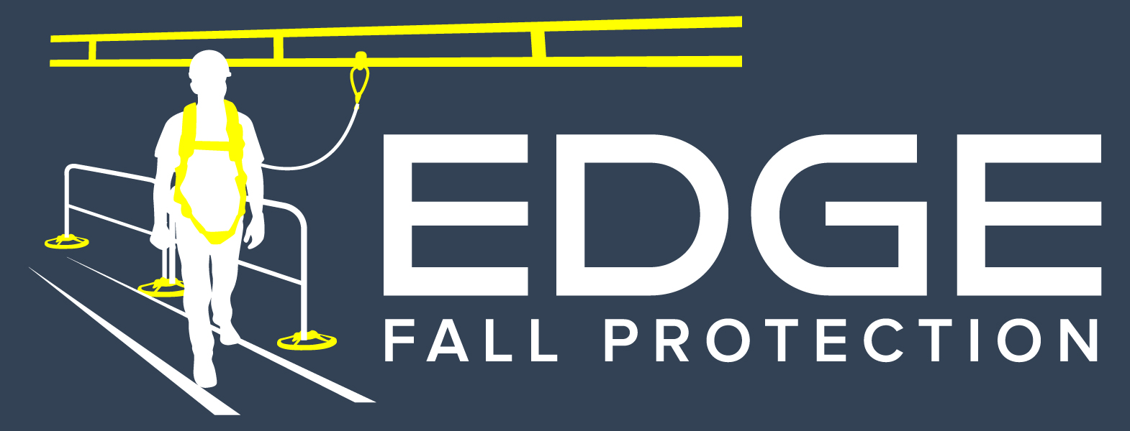

SECTION 05522

Metal Guardrail and Rooftop Fall protection

sales@edgefallprotection.com
www.edgefallprotection.com

- GENERAL

  - SECTION INCLUDES

    - Rooftop Fall Protection Parapet Wall Clamp

  - RELATED SECTIONS

    - Section 05500 – Metal Fabrications: Associated metal supports.

    - Section 05510 – Metal Stairs and Ladders.

    - Section 05515 – Ladders.

    - Section 07700 – Roof Specialties and Accessories.

    - Section 07400 – Membrane Roofing: Coordination of roof edge protection installation.

    - Section 07411 Membrane Roof Panels: Coordination of roof edge protection installations.

  - REFERENCES
    - Occupational Safety & Health Administration (OSHA)
      - 29 CFR 1910.23 – Guarding Floor and Wall Openings and Holes
      - 29 CFR 1910.27 - Fixed Ladders.
      - 29 CFR 1926.500 - Scope, Application, and Definitions Applicable to this Subpart.
      - 29 CFR 1926.501 - Duty to Have Fall Protection.
      - 29 CFR 1926.502 - Fall Protection Systems Criteria and Practices.
      - 29 CFR 1926.503 - Training Requirements.
    - California Occupational Safety & Health Administration (CAL OSHA)
      - 3209 Standard Guardrails
    - American Welding Society (AWS) D1.1/D1 - Structural Welding Code – Steel
      - AWS D1.1 – Structural Welding Code – Steel.
      - AWS D1.3 – Structural Welding Code – Sheet Steel
    - Design Standards
      - American Institute of Steel Construction (AISC) 325-11 [14th ed.] – Steel Construction Manual
      - International Building Code (IBC) [2012] – Building Design Manual
      - American Society of Civil Engineers (ASCE/SEI) 7-10 – Minimum Design Loads for Buildings and Other Structures

  - SUBMITTALS

    - Submit under provisions of Section 01300.

    - Product Data: Manufacturer's data sheets on each product to be used, including:
      - Preparation instructions and recommendations.
      - Storage and handling requirements and recommendations.
      - Installation methods.

    - Shop Drawings: Drawings showing plans, elevations, sections and details of components. Show member sizes and part identification, fasteners, anchors, fittings and evidence of compliance with structural performance requirements.

  - DELIVERY, STORAGE, AND HANDLING

    - Deliver materials to the job site in good condition and adequately protected against damage as handrails are a finished product.

    - Inspect rail sections for damage before signing the receipt from the trucking company. Truck driver must note damaged goods on the bill of lading if damaged product is found

    - Store products in manufacturer's unopened packaging until ready for installation.

    - Products to be palletized and labeled by roof level or designated drop zone.

  - PROJECT CONDITIONS

    - Field Measurements: Where handrails and railings are indicated to fit to other construction, check actual dimensions of other construction by accurate field measurements before fabrication.

  - WARRANTY

    - Warranty: Provide manufacturer’s limited two year warranty.

- PRODUCTS

  - MANUFACTURERS

    - Acceptable Manufacturer: EDGE Fall Protection, LLC, which is located at in Minneapolis, MN 55419. Contact: E-mail: sales@edgefallprotection.com Website: www.edgefallprotection.com Toll Free/Fax: 844-314-1374.

    - Substitutions: Not permitted.

    - Requests for substitutions will be considered in accordance with provisions of Section 01600.

  - Rooftop Fall Protection

    - Provide Non-Penetrating Parapet Wall Clamping Rail by EDGE Fall Protection LLC. Contact: Sales@edgefallprotection.com ; TF/Fax: 844-314-1374. System is a non-penetrating freestanding barrier system on roof, consisting of zinc parapet clamp and steel guardrail.
      - System is placed over parapet and tighten to 34 pounds of torque to secure the parapet wall clamp in place.
      - Height: 42 inches (1067 mm) +/- 3”.
        - Field verify
      - Railings:
        - 1-5/8 inch (41 mm) O.D. hot rolled pickled electric weld tubing, free of sharp edges and snag points.
        - 1-1/4 inch I.D. schedule 40 pipe by 21 foot length, to be assembled free of sharp edges and snag points. Field trim pipes to fit application on corners or terminations.
          - Connections; Join pipe railing lengths together with approved splice fittings. Tighten all set screw connections to 29 ft. lbs.
          - Modular Pipe Fittings to be cast iron fittings manufactured to the requirements of ASTM A 47-77-32510
        - Finishes:
          - Powder Coated Safety Yellow
          - Hot-Dipped Galvanized
          - Architect approved powder coated finish
      - System meets federal OSHA guidelines that requires a 200 lb load capacity.

- EXECUTION

  - EXAMINATION

    - Do not begin installation until ladders have been properly prepared and attached to substrate or structure.

    - If substrate preparation is the responsibility of another installer, notify Architect of unsatisfactory preparation before proceeding.

  - PREPARATION

    - Clean surfaces thoroughly prior to installation.

  - INSTALLATION

    - Install in accordance with manufacturer's instructions.

  - PROTECTION

    - Protect installed products until completion of project.

    - Touch-up, repair or replace damaged products before Substantial Completion.

END OF SECTION

